Business school “Vzmakh”

8 Form

Indians` genocide

Technical equipment: computer, screen, projector

Kuteynikova Mary.
English supervisor: Kondratov A.A., head English teacher; Gamaleeva E.A., English teacher.
Russian supervisor: Semenova A.

Saint Petersburg

2010

Contents

Introduction............................................................................................................................................p.3
Chapter 1. Life of American Indians before colonization......................................................................p.5
Chapter 2. 1. Genocide version..............................................................................................................p.6
Chapter 2. 2. Alternative version.........................................................................................................p.10
Chapter 3. Analyses.............................................................................................................................p.12
Conclusion............................................................................................................................................p.13
Application...........................................................................................................................................p.14
Sources.................................................................................................................................................p.18

Introduction

This summer I read some books connected with American Indians (or Native Americans), where their life and culture were described. While I was reading, at first I did not understand Native Americans, I thought that they are not developed and their culture is culture of backwards. But after some period of time, when I read more, my opinion changed. I realized, how great and specific their culture was and I really liked it. I even started to respect Indians for their love to Earth. After that the problem of Indians’ genocide became interesting for me. I could not believe that Europeans exterminated this developed race with specific culture only because of land. So I decided to know more about this problem. It was difficult to find literature on English, so I used Internet.
My opinion is that the problem of Indians` genocide is very important, because genocide against many particular groups is widespread today. The discrimination of the Native American population is only one example of this cruel destruction.
I am sure that if people know that there was genocide it would help them to restore history. Secondly, if people understand that genocide is awful, this understanding will help them not to make similar mistakes in the future.
The main problem in my report is if there was genocide or not and whether white settlers are guilty of it.
For understanding problem of genocide better it is important to know more about Indians` nature. So in first chapter of my report I will tell about life of Native Americans before colonization.
In the next chapter I will tell you a version which main point is that extinction of American Indians must be carried to genocide. Also there I will consider as occurred genocide of Indians.
Genocide problem is studied enough, but only recently people have started to reflect on the new, absolutely not studied theory that, probably, there was not any genocide. This version is, certainly, disputable, but it interested me, and I will also review it briefly.
In my last chapter I will make analyze of two versions.
After that I will try to draw the conclusion where I will express my personal opinion.

Chapter 1. Life of American Indians before colonization.

In opinion of most scientists, settling of America by ancient people of mongoloid race, which on the structure of skull much reminded Eskimos and American Indians, over 30 thousand years, began back from north-eastern Asia. So, small groups of hunters, moving after animals, unaware that, became the discoverers of America. The most ancient inhabitants of the American lands combined hunt on large mammals (mammoths, deer and bears) with a collector. With the change of climate and migration of animals, which they hunted on, ancient people moved in other parts of mainland and opened new earths.
These ancient people united together, creating tribes. There were a great number of such tribes in America (picture 1, a, b). Every tribe had the own way of life, often depending on climate, language, consuetude and traditions which made the Indian culture on the whole.
American Indians obtained itself squeak, the same as and their ancestors, by hunting and collecting. They hunted on deer, in some tribes on elk, sometimes on otter and beavers. Hunt was a pound or passive, with placing of traps. Those, who lived on coasts, fished, hunted on marine animals (seals, whales). Some tribes, for example, Cherokees, followed the plough also. They grew a corn, tobacco, bob, pumpkin and sunflower.
American Indians were able to prepare food. They cooked porridge and soups in waterproof small baskets, dropping burning hot stones in them. American Indians of north forest area invented pemmican – food from the dried meat, marrow and fat, which was kept in birch bark boxes about three years.
Tribes which lived in the north wore clothes from a skin and fur. In winter they carried a fur shirt, in summer suede (for men up to knees, for women to the ankles). They had trousers; a soft shoe – moccasins, gloves, which they carried even in summer, warding off a bloodsucking insect.
They decorated themselves with feathers and painting on body (picture 2). Simple hunters could have only one-two hawk's or eagle feather, and elders or leaders of tribe had difficult feather attires (picture 3). Indians considered that to the man who carries a military head-dress from the feathers of eagle, neither bullets nor arrows are frightful.
More frequent than all paintings of body dirt or natural paints were used during different ceremonies. American Indians painted themselves in everyday life also. It is possible it was easily to know on in-use colors and patterns, what tribe he belonged to, with whom this tribe wages war and other information. A favourite color was red, from the here widespread name of American Indians is "redskins".
Native Americans had the religion. All religion of American Indians consisted from love and respect to Earth. As American Indians considered the whole surrounding world creation of Great Spirit, they named earth sacred. Sacred was and all that, that existed on this earth: animals, plants, forces of nature. They had feeling of unity with nature, aspiring to harmony with it.
The keepers of religious ceremonies were shamans. Shamans possessed many knowledge: how to cure illness; how to bring over success to the hunter; how to predict a weather and future. They knew the laws of life and helped the people in ceremonies.
American Indians had a great number of different ceremonies. One of major ceremonies of most tribes was smoking of the World Tube - in fact, it was a prayer (a tobacco had a religious value and used in the most solemn cases; in everyday life American Indians smoked mixture with addition of willow bark and other plants).
Among the Indian ideals one of major places occupies glory of lucky warrior and hunter. Any boy from any tribe from babyhood dreamed about soldiery exploits. It is necessary to mark that before arrival of Europeans war between the tribes of North America ever did not carry bitter and sanguinary character. They all had land, and a fight was conducted not for territories or dominant position, but rather from a consuetude. Battle actions were sudden raids of small soldiery detachments, ambushes and local collisions more frequent than all. A number of hostile victims were not the main criterion of success on war: for a warrior it was important to show the personal bravery, resourcefulness and firmness. It was enough simply to put enemies to run and put to death 5-10 from them (but not 100 or 1000), that a fight was considered successful. Therefore scales of battle actions and inflicted an enemy the damage of value was not had - the fact of success, victories, was important. Military glory made basis of authority of any man promoted his social status and opened possibility to become a leader. Even consuetude to take off scalps was the not display of cruelty or barbarism, but dictated a necessity to extract a trophy, serving as in the eyes of fellow tribesmen evidence of success in a fight.
Only during colonization, when different tribes were attracted as allies of opposing in America European powers and were forced to enter into a competition from the loss of the earths, wars between American Indians purchased a wide enough scope, and scalps became the article of purchase-sale.
So, know we could see that Native Americans had their culture and traditions.

Chapter 2. 1. Genocide version.

Genocide is the systematic and planned extermination of an entire national, racial, political, or ethnic group.
Genocide entered international law for the first time in 1948; the international community took notice when Europeans (Jews, Poles, and other victims of Nazi Germany) faced cultural extinction.

"In 1492, Columbus sailed the ocean blue". . . and made the first contact with the Indians. For Native Americans, the world after 1492 would never be the same. After this date persecution and genocide of Native Americans begun. The population of the America prior to European contact was greater than 12 million. Four centuries later, the count was reduced by 95% to 237 thousand.
Genocide was an important cause of the decline for many tribes.
The Indians were not prepared to give up the nomadic life of the hunter for the sedentary life of the farmer. The new Americans, convinced of their cultural and racial superiority, were unwilling to grant the original inhabitants of the continent the vast preserve of land required by the Indians’ way of life. The consequence was a conflict.
The violent collision between whites and America's native population was probably unavoidable. Between 1600 and 1850, a dramatic surge in population led to massive waves of emigration from Europe, and many of the millions who arrived in the New World gradually pushed westward into America's seemingly unlimited space. No doubt, the 19th-century idea of America’s "manifest destiny" was in part a rationalization for acquisitiveness, but the resulting dispossession of the Indians was as unstoppable as other great population movements of the past. The U.S. government could not have prevented the westward movement even if it had wanted to.
After the first trip Christopher Columbus wrote, that American Indians lived in peace and friendship, they were happy and good-natured. Out of all of it a conclusion was made, that it is necessary to enslave them.
Mass killing did not cease, however, after Columbus departed.
In 1497 Jovanny Cabot, who worked on English king Henry VII, reached the seaside of Canada, in 1500 – 1501 Brasilia was discovered. In 1500 first town was found in America.
First English colony Jamestown appeared in 1607 in Virginia. During 75 years after appearance of Virginia appeared 12 more colonies.
To stimulate people on war against American Indians, to every invader good earth in a permanent property was promised. American Indians – proprietors of these earths – were outlawed. Soldiers were paid by large money for every scalp of the killed American Indian. Legislative Assemblies of colonies of New England appointed the high price from 50 to 100 pounds sterling for each delivered scalp, including for scalps of American Indians` women and children.
American Indians were accustomed to drinking, were incited on each other. They were cheated. There was an occasion when the contract with one of the tribes of taking their earth for 50 cents for an acre on the purchase of 8 million acres has been concluded. Later these earths were on sale to gold miners on 30 thousand dollars for an acre. The modern territory of Manhattan has been selected from Indians also by a deceit.
Many Native Americans were killed in war.
Invaders ignored proprietary rights and interests of American Indians and almost from the beginning declared them war on extermination. Certainly, armed with arrows, American Indians could not contest with colonists indiscriminate. In the armed fights large numbers of American Indians were killed when just one invader was killed.
When men were killed, colonists attacked the Indian settlements, where were only women, children and old men, and pitilessly killed them.
White settlers were very cruel. After royal expedition to «the New world», to Spain there were many "gold hunters" behind gold which organized private expeditions. Kings gave the land to colonists and allowed them to force natives living on them to sow fields and to put kitchen gardens for «new owners». Spaniards not only established laws in which they could kill Indians as punishment, but also frequently simply betting on who can split the person from top to bottom. Returning with the third expedition, Columbus brought with him dogs, which were trained for attacking people. Very soon Spaniards` dogs were fed with killed Indians. Children were considered as the special delicacy. Colonialists let dogs to gnaw them when they were alive, often in presence of their parents.
The discovery of gold in California, early in 1848, prompted migration and expansion into the west. In California and Texas there was blatant genocide of Indians by non-Indians during certain historic periods. In California, the decrease from about a quarter of a million to less than 20,000 is primarily due to the cruelties and wholesale massacres perpetrated by the miners and early settlers.
These immigrants, mostly young single males, exhibited animosity from the start, trespassing on Indian lands and often freely killing any who were in their way. An American officer wrote to his sister in 1860: "There never was a viler sort of men in the world than is congregated about these mines."
One of the most violent acts, between white settlers and Indians from tribe Yuki lasted for several years and was waged with great ferocity. By 1864 the number of Yukis had declined from about 5,000 to 300.
In addition, one of the most substantial methods was the premeditated destructions of flora and fauna which the American Indians used for food and a variety of other purposes. Probably one of the most ruinous acts to the Indians was the disappearance of the buffalo (picture 4, a). For the Indians who lived on the Plains, life depended on the buffalo (picture 4, b). At the beginning of the nineteenth century, there were an estimated forty million buffalo, but between 1830 and 1888 there was a rapid, systematic extermination culminating in the sudden slaughter of the only two remaining Plain herds. By around 1895, the formerly vast buffalo populations were practically extinct. The end result was wide scale starvation and the social and cultural disintegration of many Plains tribes.
We now also know that the Indians were intentionally exposed to smallpox by Europeans. Blankets, on which people with different mortally dangerous illnesses slept were given to Indians. An example is written below.
Once on Missouri merchants appeared from other trading post, and began to buy up a commodity at more bargain price. Then the merchants of old trading post decided to "punish" American Indians, handed over a commodity to their competitors. In 1837 a steamship with person who had a sick pox was sent in the trading post of Fort-Union. In a trading post blood of pox patient was entered to all of Indians. After a month, all tribe became ill with a pox. The story of manager a trading post Fort-Mackenzie, which visited one of the countries of the infected American Indians, to find out how an infection operates, was saved. He saw that hundreds of dead bodies weltered among wigwams and only two surviving Indians sang funeral songs.
A second incident occurred on June 20, 1837. On that day the U.S. Army began to dispense “trade blankets” to tribe Mandans and other Indians gathered at Fort Clark on the Missouri River (in present-day North Dakota). Far from being trade goods, the blankets had been taken from a military infirmary in St. Louis quarantined for smallpox, and brought upriver aboard the steamboat St. Peter’s.
When the first Indians showed symptoms of the disease on July 14, the post surgeon advised those camped near the post to scatter and seek "sanctuary" in the villages of healthy relatives.
In this way the disease was spread.
We also have documentary evidence that Europeans gave to Indians blankets with smallpox.
In 1763, a particularly serious uprising threatened the British garrisons on the west of the Allegheny Mountains. Worried about his limited resources, and disgusted by what he saw as the Indians’ treacherous and savage war methods, Sir Jeffrey Amherst, commander-in-chief of British forces in North America, wrote as follows to Colonel Henry Bouquet at Fort Pitt: “You will do well to try to inoculate the Indians [with smallpox] by means of blankets, as well as to try every other method, that can serve to extirpate this execrable race.”
Bouquet clearly approved of Amherst's suggestion, but whether he himself carried it out is uncertain. On or around June 24, two traders at Fort Pitt did give blankets and a handkerchief from the fort’s quarantined hospital to two visiting Indians` tribe Delaware, and one of the traders noted in his journal: “I hope it will have the desired effect.” Smallpox was already present among the tribes of Ohio; at some point after this episode, there was another outbreak in which hundreds died.

After taking lands, belongings to American Indians, Indians were declared as foreigners by invaders. On the laws of the USA (operating up to 1924!), American Indians were not the citizens of this country and did not have no rights on it.
Native Americans were pushed further deep into continent on the bad earths. Migration was carried out as a military operation of military powers of the USA and accompanied the acts of violence, mass murders and tyranny. Soldiery robbed Indian property, took a cattle.
The regular army of the USA took part in damaging of the whole villages, and also drove Indians in special reservations (there were no simple conditions of hygiene: water and bathrooms, were not medical services) (picture 5). Reservations were created in unsuitable places for agriculture. Very soon they became overflowed; therefore hunger killed hundred thousands of people.
During XVIII and XIX centuries the American Indian population almost had been completely exterminated.
White settlers damaged a high developed civilization and culture of Indians, which was approaching to Christianity views.
Organization of American Indians and some historians in the USA prove that in regard to the native inhabitants of the American continent the act of genocide was carried out, as a number of Native Americans decreased from orientation 12 millions in 1500 and to 237 thousand in a 1900.
So it was extermination, as it is said in definition of genocide.

Chapter 2. 2. Alternative version.

The facts and thoughts which corroborate the theory about that was not genocide are presented below.
Firstly, there is absolutely no question that some settlers, some military leaders, some government officials, and some states as Georgia and especially California would have exterminated all Indians. But there is absolutely no evidence that the American Government had an official (or as some claim unofficial) policy of exterminating all Indians, or that the American Government gave smallpox blankets to any Indians. The argument for Indian genocide is based primarily on a postscript in a letter written by General Jeffery Amherst to Colonel Bouquet during the French and Indian War. Letters by General Amherst and Colonel Bouquet mentioning spreading smallpox to Indians does not mean that this was ever carried out.
Secondly, genocide is a word that is easy to throw around, often to grab a reader's attention, but proving it is something else. What one group calls genocide, another group may call progress. Maybe for the world that is better to have one religion and culture, which are developed well (without Indians` idols).
Colonization of America actually was a war, in which during the certain periods and in certain territories overweight appeared on the different parties. Sometimes Indians began war operations. So, by estimates of historians, about three quarters of wars of Indians with the white have begun under Indians` initiative and their cruelty to white, and to other Indians quite often amazed Europeans. American Indians used a plain weapon, threw axes well and masterly took off scalps - after such operation only the few survived. American Indians had many tortures, also differed the special cruelty motion, so there were many deaths both with redskins and white.
As the example of Indians` cruelty the story, which is presented below could be considered.
Following the end of the Civil War, large waves of white migrants, arriving simultaneously from East and West, squeezed the Plains Indians between them. In response, the Indians attacked vulnerable white outposts; they were cruel as devils, reported one officer on the scene. The trails west were in similar peril: in December 1866, an army detachment of 80 men was lured into an ambush on the Bozeman Trail, and all of the soldiers were killed.
Also Plains Indians had little or no concept of the dangers involved with the white-man diseases. And a large amount of them died only because of it. So American Indians were infected from colonists not on purpose.
The last argument is that the purpose of white settlers was not elimination of American Indians. They needed land, and practically always, when American Indians settled for a compromise with colonists, nobody killed them, and new territory for a residence, money and other compensation was given to them. For example, tribe Siu gave to colonists some of their land and white promised to give them food, schools, weapons and peace.
However this theory is not developed fully yet, and there are many failings in it.

Chapter 3. Analysis
So, there are two opposite versions about genocide. Each of them has both pluses and minuses. Let’s review the versions.
The genocide version has two main points.
1) Almost all population of Native Americans was exterminated by white settlers.
2) Cruel methods (killing of woman and children, destroying of buffalo and others, which are presented in genocide version) were used.
The second version could be divided in three main parts, which are presented below.
- Indians did not have immunity to many diseases the white settlers had.
- Colonists did not want to kill all the Indians at first; they never planned to destroy them. Some of them needed land (English and Spaniards) and French people wanted Indians to work of them.
- Indians and white were cruel both and that was a war between to nations, when one wins – and other looses. In history there were many such examples; many nations died because of coming of more powerful enemy.
Also this version included that white settlers were not guilty.
After I carefully studied these versions, the first one seemed to me more convincing.
The reason was that the second had too much failings: elimination of American Indians can not be named progress, because American Indians were quite not backwards. They had the culture, even religion. Also some of them were highly developed. American Indians sometimes began battles and cruelly fallen out with white... But what did they have to do? Do nothing and silently watch, how belonged to them earth was being taken away? American Indians did not have immunity? If the white would not begin to arrive on Indian earths constantly, American Indians would not be infected.
Besides while colonists did not begin to take away earth for American Indians, they were adjusted benevolently. American Indians battled one's own way; in fact they had neither a cavalry nor weapon which the white disposed. And their science and medicine were not such developed.
And white settlers, as I think, could imagine that if they destroy the culture of Indians (It would be destroyed because it was less developed), kill the main animals which were used by Indians as food and give to people bad land, their nation will die at the end...
In any case, it is impossible to encroach on somebody’s territory, and exterminate people, above-ground on it the since olden time and those who first occupied territory.
At the end I came to opinion that no genocide theory is unconvincing and thought of only in an order to justify white settlers.

Conclusion

Genocide could be obvious (like genocide of Jews during the Second World War) or indirect. Genocide of Native Americans was the example of indirect genocide, so it is difficult to prove that genocide was.
I have studied the problem with two opposite positions and I have chosen the position that that was genocide. Almost all people of this race were cruelly destroyed.
But the problem is that it was not white settlers` plan. And, according to genocide’s definition, we can not say that that was genocide.
So, in fact the genocide was, but those, who want to justify white colonists, with their, as I think, unconvincing version, are formally right. And we have nothing to reply – we have no evidences.
But it is time to stop wink at colonists’ behavior! They needed land, and, to take it, they killed thousands of Native Americans. Indians used to have a developed culture – and it was destroyed too.
My opinion is that American Indians undeservedly suffered from white colonists. Almost all of them were exterminated by wars and tortures, and also indirectly - by illnesses and extermination of animals which they hunted on...
And I do not think that those who survived are lucky. They were deprived by land and were drove in wretched reservations. People, living in poverty - that remained from a developing, young culture which was based on harmony with nature.
The problem of genocide became interesting for me while I was working on my academic writing. I hope that, according to ideas I came at the end, people would consider the genocide problem (I mean any genocide, not only Indians`) carefully. For example, not only teach children history, but also tell them about right behavior on war. This simple thing, as I think, would help people not to repeat mistakes of the past.

Applications

1 a

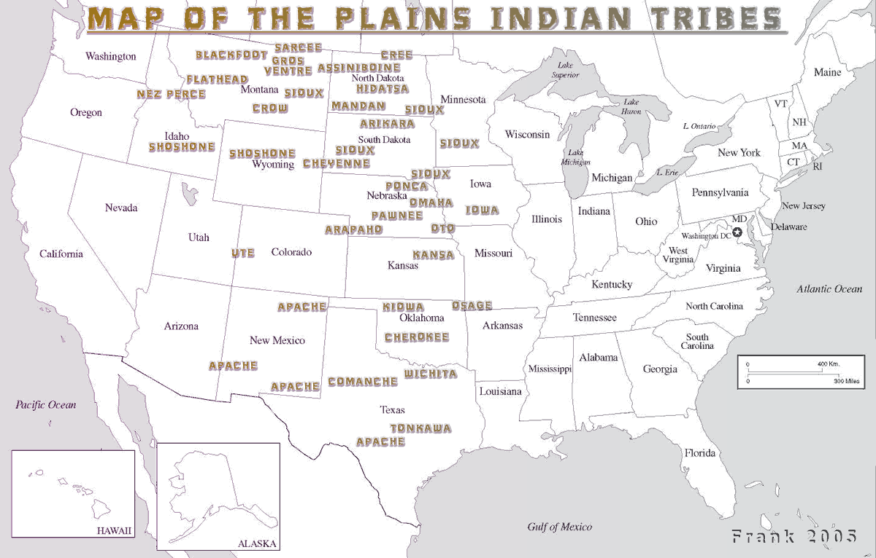

1b

2

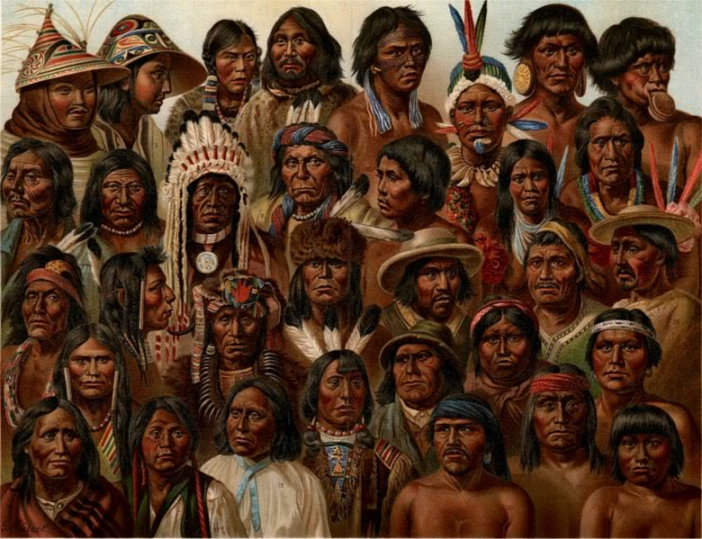

3

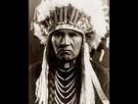

4a
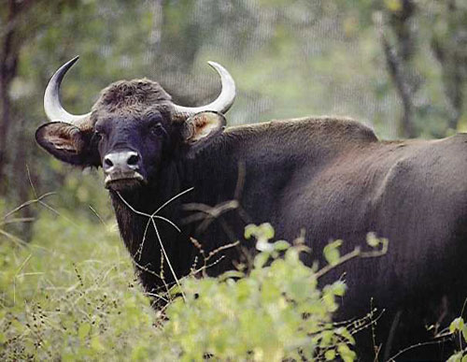

4b
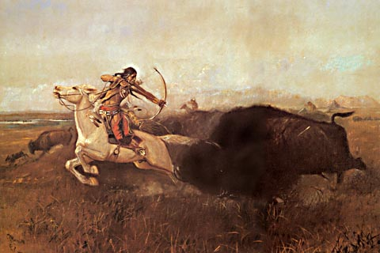
(Indian hunting buffalo)

5
(Reservations)
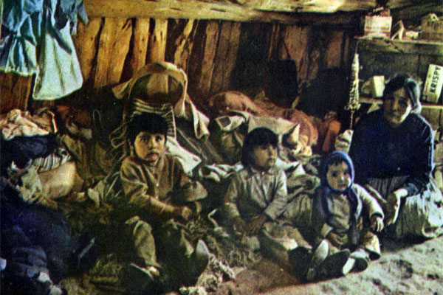

Sources

1) http://www.thefurtrapper.com/indian_smallpox.htm
O. Ned Eddins: «Plains Indian Smallpox»

2) http://iearn.org/hgp/aeti/aeti-1997/native-americans.html

Leah Trabich, Cold Spring Harbor High School, New York, USA: «Native American Genocide Still Haunts United States»

3) http://www.ei1918.ru/foreign_history/print/mify_o konkiste.html
Vittorio Messory (31.10.2008): «Myths about conquistadors».
4) http://www.infousa.ru/facts/native.htm

Sheila Orenstein (29. 01.2003): « Native Americans»

5) http://hnn.us/articles/7302.html

Guenter Lewy: “Were American Indians the Victims of Genocide?”

:)

