Analysis
of Severus Snape’s
character in the context of “Harry Potter” books series.

Iya Mazurkevich, the 8th grade.

Table of contents

Introduction

The first chapter or facts about the “Harry Potter” books series, film and about Joanne Rowling, the author

The second chapter or Snape – personality, actions, attitude, Big Game.

Conclusion.

Sources.

Introduction

I’m going to speak about Severus Snape, “Harry Potter” books series’ character. I think that my topic is of great interest. I chose it because I have always liked “Harry Potter” books series and Severus Snape was one of my favourite characters. While I was writing my essay, I found out many interesting and strange facts about his life and personality.

I chose this character because I find Snape a very interesting and not ordinary character in the book. Of course, even Joanne Rowling called him ‘an anti-hero’ in one of the interviews, but we can’t say that unambiguously. He is a frequent point at issues of Harry Potter’s fan.

In an interview Rowling described Snape's character as an "anti hero". She said that she drew inspiration for Snape's character from a disliked teacher from her own childhood, and described Snape as a horrible teacher: "the worst, shabbiest thing you can do as a teacher is to bully students".

In my essay I want to analyze this character of the Joanne Rowling’s «Harry Potter» a little bit more. I’ll tell something about him, his life and his destiny. He is a very important character in this book and, also I’ll prove it. Next, I’ll try to find out, why Joanne Rowling made him such a hero and try to find the similar characters in her life. What does she think about him?
My idea is to analyze professor Snape, the book and, also, the film. Why these series of books for children became so incredibly popular? I’ll try to find out.

Could we say that he had unhappy life? Could we really know, was he good or bad? It’s very difficult questions. I’d try to answer them too.

The first chapter or facts about the “Harry Potter” books series, film and about Joanne Rowling, the author

Joanne Rowling was born in England on 31st of June in 1965. In 1995 she finished to write the first book about Harry Potter. The first book had a great success. So, now there are many books, she wrote: “Harry Potter and the Philosopher's Stone” (26 June 1997), “Harry Potter and the Chamber of Secrets” (2 July 1998), “Harry Potter and the Prisoner of Azkaban” (8 July 1999), “Harry Potter and the Goblet of Fire” (8 July 2000), “Harry Potter and the Order of the Phoenix” (21 June 2003), “Harry Potter and the Half-Blood Prince” (16 July 2005), “Harry Potter and the Deathly Hallows” (21 July 2007), “Fantastic Beasts and Where to Find Them” (2001), “Quidditch Through the Ages” (2001), “The Tales of Beedle the Bard” (2007).

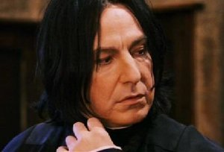
Roughly speaking, the plot of the book is the story of a boy called Harry Potter, who was born in an unusual family – wizards’ family. But his parents died and all his childhood he lived in his aunt’s family. So, he didn’t know anything about magic. But when he became eleven, a strange man gave him a letter, which invited him to “Hogwarts” – the school for young wizards. He made many very good friends and in all the books he’s trying to defeat the Dark Lord, the main evil wizard, Harry Potter’s enemy, so it’s a book, where a little but not ordinary boy became a real hero.

No one exactly knows, why “Harry Potter” book series are so extremely popular. But, if you analyze the plot you’ll understand that nothing is accidentally. Rowling thought over really everything and in fact the plot is very deep and difficult. Maybe, for a moment you’ll still think, that it’s only a fairytale, but this book has very difficult, deep and interesting plot.

Talking about the film, I can say, that all parts (from the first to fifth) were maid near to text, so in the film there are many books’ details. The most part of actors, also their appearance are very near to their characters’ appearance. Severus Snape was played in the all films by Alan Rickman, who is actually a very good actor and, in my opinion, he splendidly acted the Severus Snape’s role. He made from Snape not so cruel and bad professor, but his character became cold, strict and very imperturbable person. I think, films are as popular as books and, of course, fans like them, but there aren’t so many details, characters of books and films are not the same sometimes.

In the interviews Rickman said that work in this film was very interesting.
As an actor Alan Rickman played in such films like: “Love actually”, “Die Hard”, “Dogma” and others. Except five “Harry Potter” films of course.

In an interview on the question “Do you think that Snape is a hero?” Joanne Rowling answers: “Yes, but he’s a strange hero. Maybe he’s an anti-hero. He is very bad, “bitter”, cruel, but he loved and defended his love. And he died because of love. It’s heroic enough.”

Also, Rowling said, that Lily had some feelings to Severus and she could love him if he didn’t love dark arts too much.

One more important question is why this series of books for children became so incredibly popular?

Here is one opinion: “Having thought about this a lot over the past few years, my opinion about the books is that their success is derived not from the storyline aspects of the books, but rather from the descriptions of every-day life at Hogwarts”.

Maybe because Rowling in her books describes magic world, which could be real, because she writes about ordinary people, like all of us, about real cities. Also, she describes everyday life in “Hogwarts”, school of young wizards. Moreover, the books’ world was thought out very thoroughly. And maybe the books are so attractive because of this too.

The second chapter or Snape – personality, actions, attitude, Big Game

Severus Snape — is the most discrepant character in the “Harry Potter” books’ series. The professor of potions (1981—1996) and defence against the dark arts (1996—1997) in the school of sorcery and magic «Hogwarts», dean of Slytherin in 1981—1997, headmaster of «Hogwarts» in 1997—1998. He is one of the most mysterious and difficult heroes of the book. Also, maybe it is not so visible at first sight, but the professor plays a big and important role in the plot.

Now I’m going to tell Snape’s story – his destiny and other similar things.

Severus Snape was born on the 9th of January in the 1960th year in the family of the wizard – his mother and an ordinary man – his father. He grew up in loneliness but one time he met Lily and Petunia Evans. He recognized that Lily was a wizard, like him so all the time they were dreaming about Hogwarts.

On the 1st of September in 1971 Severus and Lily were sitting on the «Hogwarts-express», where they met James Potter and Sirius Black. They started to tease Severus, when they knew, that he wanted to study at Slytherin. On the same day Lily was assigned to Gryffindor, while Severus – in Slytherine.

In the school Snape became a member of the group, with Lucius Malfoy, Bellatrix Black, Rodolphus Lestrange, Avery, Mulciber and other slytherins (who in the future would become Death Eaters) and he is fond of potions. Also, he suffered indignity from James Potter, Sirius Black and Peter Pettigrew, who called themselves (with Remus Lupin) marauders. In the end of the 5th course Severus could die – Remus Lupin, who was a werewolf, was about to kill him, but James Potter saved Snape. But Albus Dumbledore hided this incident.

Lily Evance, Snape’s friend, defenced him all the time. Severus fell in love with her, but Lily was scared of his interest in the dark arts and attitude to other students, whose parents were muggles. But once, when marauders were teasing him one more time, Lily defended him again, but also found it funny. Because of that, Snape insulted her, so their friendship suddenly came to an end. And later she started to meet James Potter.

After school Snape became a Death Eater (1977 or 1978). And in the 1980th in the tavern “Wild boar’s head” he heard the prophesy, that there was near a man, who would defeat Lord Voldemort. Of course, it was about Harry Potter. Snape told Voldemort about the prophesy, so he decided, that was Harry Potter, because little Harry was born in the 31st of June, like it was said in the prophesy. Distracted Snape asked The Dark Lord not to kill Lily, but he didn’t listen. In that case, Snape went to Dumbledore and asked him to save Lily. In return for it he promised to do everything that the headmistress would order. From that moment Snape became Voldemort’s and Dumbledore’s spy at the same time. But he was on the Dumbledore’s side probably.

But Dumbledore couldn’t save Lily and James. After their death the headmistress persuaded Severus that the only way to redeem his fault was to save Lily’s son – Harry. Snape agreed. So Dumbledore told all his agents that Severus was his counterspy and made him the professor of potions and the dean of Slytherin. The only thing Snape could do – was to wait for Harry’ to be appeared in “Hogwarts”.

When Snape was a professor, he didn’t hide his dislike for students of all faculties, especially Gryffindor, except Slytherine of course. So he was popular only among the Slytherine students. Harry didn’t like him and treated him with fear and animosity. He thought that Severus was guilty in all the “Hogwarts’s” disasters. But he also wasn’t responsible for it. And for Harry was a surprise that he many times saved his life.

In the sixth book a reader finds out that Snape was Dumbledore’s spy. But Voldemort thought, that he was his spy. In the end of the book Severus killed Dumbledore. Harry saw that, so he came to hated him and thought that Snape was a traitor.

But next was found that Dumbledore asked Snape to kill him. It happened because the headmistress had been cursed before and he decided to die for the common good.

Because of that Snape became the trusted man and Severus, also saved Draco Malfoy from Dark Lord’s anger, because he had to kill Dumbledore, but he couldn’t. When Voldemort captured The Magic Department, Snape became the headmaster of «Hogwarts» and saved students from their new professors – Death Eaters.

Also, Severus sent Harry Godric Gryffindor’s sword (it helped Ron destroy one of Voldemort’s horcruxes). But Harry didn’t understand him and continued to hate him.

A short time previously there was the final fight with Voldemort, where Snape escaped from “Hogwarts” and joined the Dark Lord to counteract Voldemort’s plans.

Voldemort falsely thought that Snape had been Elder Wand’s master and he killed him by his snake Nagini. But before death Severus had time to give Harry his memories, so he understood that Snape was on Dumbledore’s side.

Harry understood that Snape didn’t bear ill will to him. In memory of him, Harry gave his son the second name Severus (Albus Severus Potter).

Among Harry Potter’s fans there is such a term as Dumbledore’s Big Game (further – BG). This term means that Dumbledore controls the larger quantity of books’ actions. So the biggest part of fights, teachers’ actions and other things are under the headmaster’s control. For what is BG organized? Game is conducted only with the purpose of training Harry and forming his personality - in view of forthcoming fight with Voldemort.

Snape took an immediate part in it. He played a role of a strict professor, who prevented Harry from conceit. He must show, that Harry didn’t know everything, for him not to be too self confident. But sometimes he tried too hard, so Harry felt himself guilty in all deadly sins.

For the first time Snape showed the same feelings, but from the end of the seventh book we can understand that he became attached to Harry and he really didn’t want his (Harry’s) death.

Also, Snape always had to make show of his fidelity to Voldemort. For example, all people around thought, he wanted to be a professor of defence against the dark arts, but that was only a visibility - in an actual fact he never wanted that. So, that only seemed the sign of devotion to Voldemort.

In the third book Snape’s part in the Big Game is exactly more important, than in the first two books. And in the third part, actually raises a question about marouders. Severus has a very difficult attitude to Lupine, and we can see that all book.

Also, in the end of the third book, while Lupine, Sirius, Harry and company shouting on each other, Snape comes in. He hates Sirius Black, so he wants to kill him. Here we can se one of the Snape’s character qualities. He is ready to say a spell and asks Sirius to give him a cause to kill him. Here is Snape’s strain: he always needs a reason.

He’s character is not ordinary. The most interesting thing is that we can’t really say who he is. Maybe, he wants to look like very strict, dark and cold professor, but, we can’t say anything, looking through the books because we see things in the books through Harry Potter’s eyes, and they exactly haven’t ever seen what the Snape’s heart is like.

Conclusion

Finally, I can make some decisions about mysterious professor:
1. In spite of all Harry’s suspicions, Snape came to the Dumbledore’s sight long before actions of the first book. The best source – his memories from the 5th – 7th books.
2. Often many actions that Joan Rowling writes about are not as simple as it seems. For example, we can understand that Severus never wanted to be the professor of defense against the dark arts. We can find basis of this, from reading his first lesson (“Harry Potter and the Prisoner of Azkaban”) of his “favourite” defence against the dark arts. The whole lesson unhappy students read their books, Snape didn’t say anything useful.
3. All his life he felt strange attachment to marauders. But they didn’t understand each other, so dint of many mistakes (which were made by each side) their ways dispersed once and for all.
So, I can sum up that Snape had difficult, unhappy and not existing life. He had a role of “very bad professor” in Harry’s life and misunderstood teenager in his childhood. So, that is the matter why he is always so closed and cold.
But, in spite of everything and disregard his horrible personality, he most of time perform golden deeds.

Sources

ru.wikipedia.org/wiki

en.wikipedia.org/wiki

http://everything2.com

http://big-game.livejournal.com

Applications

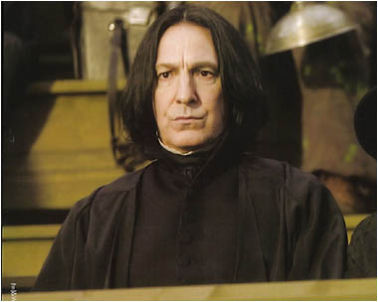

Severus Snape from the film.

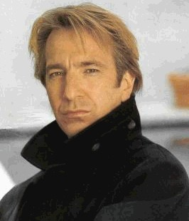

Alan Rickman. The actor, who acted Snape in the film.

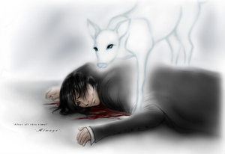
Fan Art.

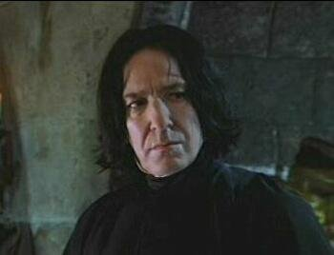

Severus Snape from the film.

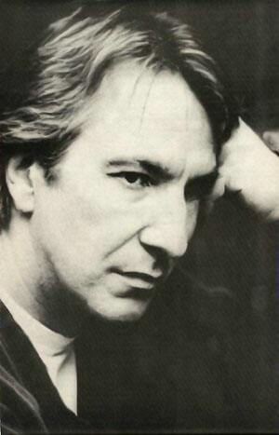

Alan Rickman. The actor, who acted Snape in the film.

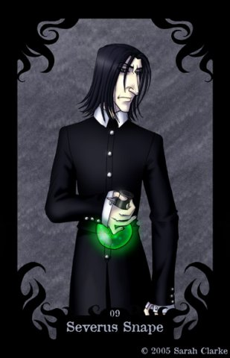

Fan Art.

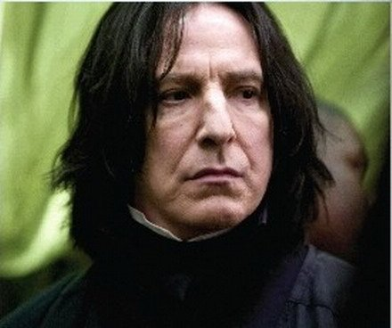

Severus Snape from the film.

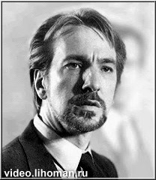

Alan Rickman. The actor, who acted Snape in the film.

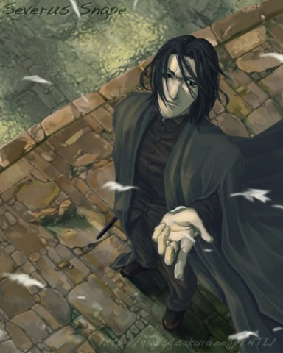

Fan Art.

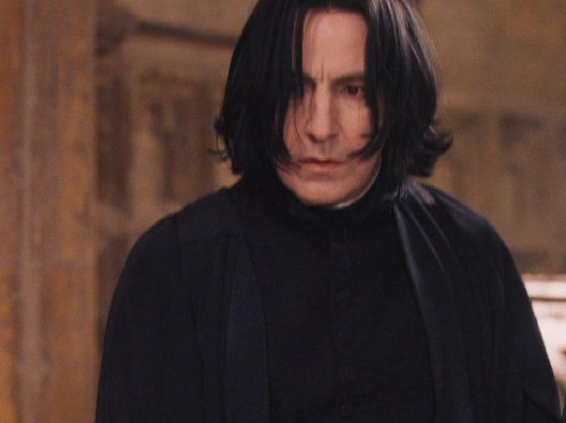
Severus Snape from the film.

.
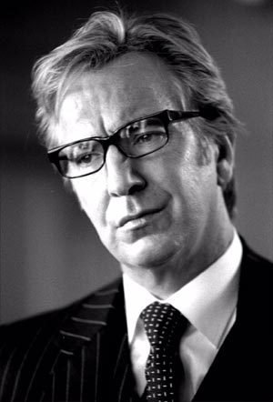

Alan Rickman. The actor, who acted Snape in the film.

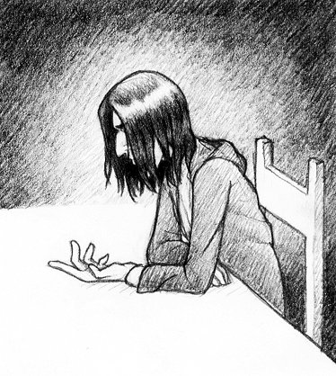

Fan Art.

